#Visualizing Kenyan farmers question frequency
import pandas as pd
import matplotlib.pyplot as plt

# Load your dataset
df = pd.read_csv("processed_questions.csv", encoding='latin1')

# Inspect columns if needed
print(df.columns)

# Plot the time series
plt.figure(figsize=(12, 6))
plt.plot(df["Farmers_questions"], df["Question_frequency"], marker="x")
plt.title("Kenyan Farmers question frequency")
plt.xlabel("Questions")
plt.xticks(rotation=90)
plt.ylabel("Frequency")
plt.grid(True)
plt.tight_layout()
plt.show()

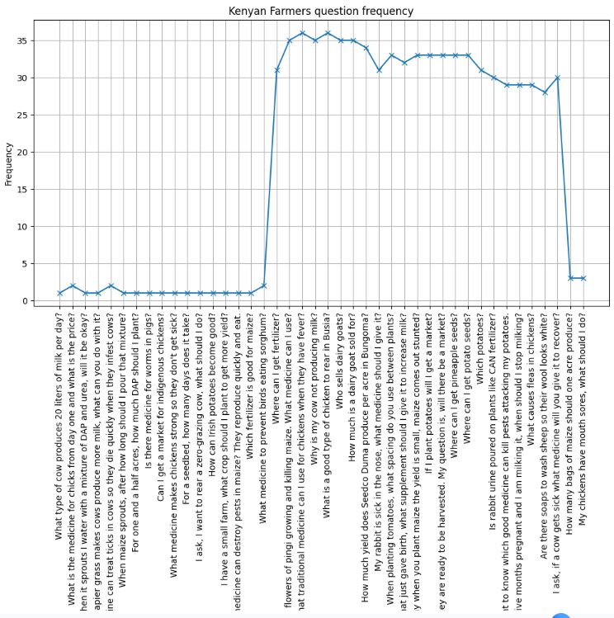

PYTHON CODE FOR WEATHER INFLUENCE ON KENYAN FARMERS QUESTION (PLOTTING LARGE VALUE COLUMNS AND SMALL VALUE COLUMNS ON SEPARATE Y-AXIS I.E., LEFT Y-AXIS AND RIGHT Y-AXIS)

import pandas as pd
import matplotlib.pyplot as plt

# Read CSV
df = pd.read_csv("processed_questions.csv", encoding='latin1')

# x-axis value
df['X_Label'] = df['Farmers_questions'].astype(str)

# Create figure and first axis
fig, ax1 = plt.subplots(figsize=(12,6))

# Plotting first 3 columns with lower values on left y-axis
ax1.plot(df['X_Label'], df['Question_frequency'], marker='o', label='Question_frequency')
ax1.plot(df['X_Label'], df['Avg_Min_Temp/oC'], marker='s', label='Avg_min_Temp')
ax1.plot(df['X_Label'], df['Avg_Max_Temp /oC'], marker='^', label='Avg_Max_Temp')
ax1.set_xlabel("Farmers Questions")
ax1.set_ylabel("Value1")
ax1.tick_params(axis='x', rotation=90)

# Create second y-axis for larger precipitation value
ax2 = ax1.twinx()
ax2.plot(df['X_Label'], df['Avg_Precipitation /mm'], marker='d', color='red', label='Avg_Precipitation')
ax2.set_ylabel("Value2")

# Combine legends
lines, labels = ax1.get_legend_handles_labels()
lines2, labels2 = ax2.get_legend_handles_labels()
ax1.legend(lines + lines2, labels + labels2, loc='upper left')

plt.title("Weather Influence on Kenyan Farmers Questions (Dual Y-Axis)")
plt.tight_layout()
plt.show()

